
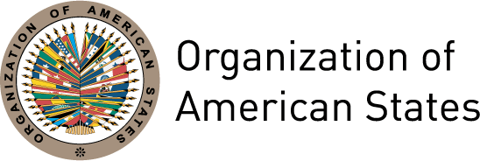

Message from Rocío García Gaytán,

President of the Inter-American Commission of Women of the OAS

International Women’s Day

March 8th 2012

“Empower Rural Women – End Hunger and Poverty”

This year, the commemoration of International Women’s Day constitutes an opportunity to reflect on the empowerment of some 58 million rural women in the Americas

The work of rural women and girls contributes to agricultural production, to food security and to sustainable rural development. For this reason, they should play a central role in decision-making processes at all levels.

In this second decade of the XXI century, during which democracy and governance in our region confront innumerable challenges, we find ourselves facing the pressing challenge of generating the conditions that will guarantee the full exercise of women’s citizenship at the local level, in a situation of equality with men and at all levels of decision-making.

In this sense, we echo de message of Michelle Bachelet, Under-Secretary General and Executive Director of UN Women, when she states that “no enduring solution to the major changes of our day—from climate change to political and economic instability—can be solved without the full empowerment and participation of the world’s women.”

The Brasilia Consensus, adopted at the XI Regional Conference on Women in Latin America and the Caribbean, the Declaration of the Inter-American Year of Women, adopted at the XXXV Assembly of Delegates of the Inter-American Commission of Women, and the CIM Strategic Plan 2011-2016 constitute the basis for the inter-governmental agenda on women’s rights in our region.

For this reason, the synergies between international and inter-governmental organizations, the national mechanisms for the advancement of women, the women’s movement and civil society, as part of the new gender architecture of the XXI century, are fundamental to the fulfillment of these mandates and to breaking down the structural inequalities, violence and discrimination the rural women in the Americas continue to face.

The full text of this statement is available at: http://www.unwomen.org/2012/03/message-of-michelle-bachelet-executive-director-of-un-women-on-international-womens-day-2012/

